
Penguin Rep Theatre 2024-2025
Student Playwright Festival

Budding playwrights in regional high schools and colleges are invited to compose and submit a 10-minute play for an upcoming Penguin Rep Theatre Playwright Festival. For over 45 years, Penguin Rep has been home to stellar original productions featuring Actors’ Equity stars of stage and screen, including Tony, Emmy, and Oscar award winners.

Up to six student plays will be selected for a public reading by professional actors at Penguin Rep in Stony Point in the spring of 2025. Students’ one-act plays on any topic/theme will be reviewed by a team of professional theater personnel, including actors, directors, and trustees. Detailed instructions and a sample script are provided herein. All entrants will receive certificates of recognition for their submissions and the authors of the selected scripts will receive a $100 stipend.

Award-winning author, playwright, literary manager, and educator, Angelo Parra, will be
available via a Zoom meeting to offer feedback on selected writers’ scripts before the public readings. Also, his book, Playwriting for Dummies, will be given to the selected playwrights.

Guidelines are as follows:

- Plays must be typed and should be in standard play format (see sample). They should include setting, characters, dialog, and stage directions.
- Original one-act plays may be up to 10 pages in length and approximately 10 minutes in duration.
- Student playwrights must be in grades 9-12 or in college during the 2024-2025 school year. This includes attending any of Rockland County’s public or private high schools or home schooled, as well as local two or four-year colleges.
- Plays should feature 1 to 4 characters.
- The application (attached) must list your name, home address, email, phone number, school, and grade/year, play title, play topic, and list of characters’ names with pertinent descriptions (i.e., age, gender, role/occupation).
- Applications and plays should be submitted to Penguin Rep via email by May 1, 2025 at festival@penguinrep.org.

Penguin Rep is a nonprofit theatre company, entertaining audiences for over 45 years. Penguin Rep, dubbed “the gutsiest little theatre” by the NY Times, was founded by Joe Brancato, Artistic Director. It is a professional theatre dedicated to promoting new voices and works, as well as nurturing new talent for the stage. Under the leadership of Mr. Brancato and Executive Director, Andrew M. Horn, Penguin Rep has attracted more than 150,000 audience members from the NY metropolitan area to its intimate 108-seat theatre in Stony Point, NY.

Penguin Rep 2024-2025
Student Playwright Festival Application

Student Name:

Address:

Phone:

Email:

School:

Grade/Year:

Title of Play:

Setting: Time period:

Sample Themes:

_____ Heroism

_____ Social/historical issues

_____ Love and/or loss

_____ A big risk
_____ Friend to the end

_____ Environmental issues

_____ A major challenge

_____ Evolving…

_____ Any situation or subject of your own choosing (List topic below.):

_________________________________________________________________

Page 1

Characters (up to four):

Name Age Range Brief Description

Feel free to contact Penguin Rep via email (festival@penguinrep.org) with any questions you may have.

Enjoy this opportunity to have your creative voice heard!

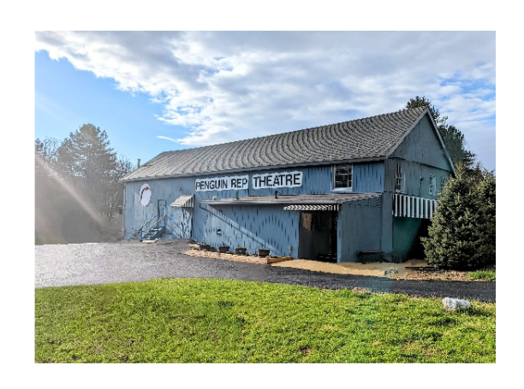

Page 2

SAMPLE SCRIPT

Journey of the Heart Angelo Parra (09-11-12)

TOM
Yes. I'm the new member of the Patient Review and Ethics Committee. (A beat) This is the boardroom, isn't it?

HUNTER
Yes, yes, yes. It's just that… well.

(After a moment HUNTER offers his hand)

I'm Dr. Hunter. Hectic morning. You know how that is.

TOM
Of course. Do you head the committee?

HUNTER
No. I'm Chief of Surgical Transplantation. (Helpfully) Why don't we jog down to my office, and I'll tell you about our work.

TOM
Isn't the meeting held here?

HUNTER
Yes, but I, eh, really must advise you that this is probably not a good meeting for you to sit in on. Some last-minute, extremely complicated issues have come up, I’m afraid.

TOM
No problem. I'm a quick study.

HUNTER
No doubt, but, for a first meeting, I think it just wouldn't be representative of what we do. So, let’s set up a time for us to meet in my office so that I can get you up to speed. Then you'll hit the ground running. I'll phone my secretary right now.

(LINDA, 30ish, carrying a folder, enters the room, unnoticed by TOM and HUNTER)

TOM
Dr. Hunter, the invitation to participate came directly from the chairman of the board of the medical center, effective immediately. However, if you feel my presence here is inadvisable, we can jog down to Mr. Vandermark's office to see what he thinks.

